Garbage classification using CNN
Project Report

1.Introduction
1.1 Problem Statement
Garbage Classification The accumulation of solid waste in the urban area is becoming a great concern, and it would result in environmental pollution and may be hazardous to human health if it is not properly managed. It is important to have an advanced/intelligent waste management system to manage a variety of waste materials. One of the most important steps of waste management is the separation of the waste into the different components and this process is normally done manually by hand-picking. To simplify the process, we propose an intelligent waste material classification system, which is developed by using the Convolutional Neural Network model which is a machine learning tool can classify the waste into different groups/types such as glass, metal, paper, plastic,,cardboard,trash.
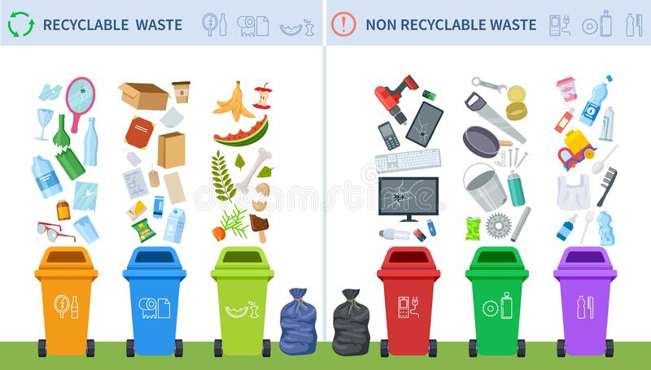

1.2 Explanation-
In this project we just take dataset from Kaggle in which there are six different classes such as glass, metal, paper, plastic,cardboard,trash .Frist step is to break the dataset into train and text after this the we perform data preprocessing(like-ImageDataGenerator) after this we build the model.
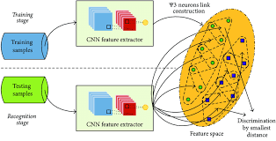

by loading the preprocessed data and adding the CNN layer ,adding Dense layers
and train and test the model.After this all we just save our model.
For application building we use
1.Building web API
2. Creating an user interface

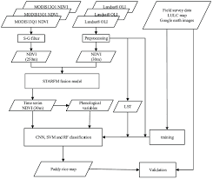

1.3 Tools and library

- CNN
- Keras
- Flask
- HTML and CSS
1.4
Important links :
- Kaggle - https://www.kaggle.com/asdasdasasdas/garbage-classification
- Tutorialspoint-https://www.tutorialspoint.com/index.htm
- Keras- https://www.tensorflow.org/api_docs/python/tf/keras/preprocessing/imaorge/ImageDataGenerat
1.5Conclusion:
Use this model !
- We just upload an image from the given six classes.
- Our model able to predict from which class does this image is belong.
- This machine learning help preventing infection and poplluation
- The accuracy of this model may be increased in future
- If everything is working properly, the garbage classification will initialize for about 10 seconds and then display the image group name.!
Acknowledgement –
I would like to Thanks Smartbridge team for mentoring me throughout this project. I have learnt a lot and learned new skills.

Abhishek Singh
abhisheksi1899@gmail.com

------------------------------------- Thank you! --------------------------------------

